# Sentiment Analysis of COVID-19 Tweets – Visualization Dashboard

## INTRODUCTION

### Overview:

Sentiment Analysis is a field of Natural Language Processing responsible for systems that can extract opinions from natural language. NLP targets creating pipelines that can understand language like we humans do. Sentiment analysis is one of the most basic problems in NLP and is usually one of the first problems that students face in a Natural Language Processing course. Nowadays, the problem of disease such like covid-19 is effecting a lot many countries. There are many ways to fight against Corona. From those, lockdown is one of the most important parts. People are facing many problems due to lockdown. Twitter is not only a place for people to respond to others’ tweets but also a platform to post your tweets and share your feelings. Thus, besides likes/replies/retweets, we also mined the content of COVID-19 related tweets to see how people’s feelings and expressions changed over time. Twitter is a platform where we get many kinds of sentiment at one place.

### Purpose:

Our analysis has shown some relationships between confirmed cases’ growth and the trends of sentiments. With more granular data such as geographic data, demographic information, and so on, further insights can be generated, such as public sentiment monitoring the hardest-hit areas. With a more specific target, the analysis would be more valuable for institutions or governments to take action.

## LITERATURE SURVEY

### Existing problem:

We are working on the situation of COVID-19. At this time many incidence are occurs which cannot be imagined by normal humans. People are not able to think about how to deal with this situation. Sentiment Analysis is the process where we analyze people’s sentiment. When we analysis sentiments we faced many challenges regarding datasets. By applying machine learning we train our dataset. When we create the final dashboard of our result so the main problem which we faced is that our result is visual but does not work on the voice commands.

### Proposed solution:

We conducted an analysis by utilizing the BERT model. BERT is Google’s pre-trained model that can be fine-tuned for a wide range of NLP tasks. Here in our case, we used in combination with IBM’s Watson Tone Analyzer to label the tweets with 5 sentiment types. At first, we used TextBlob to explore public sentiments, which showed an upward trend in being steadily more positive. Then we did in to analyze the sentiments on a more detailed level, in a multi-dimensional way, to reveal the trend more comprehensively. we used the IBM Watson Tone analyzer along with manual tags to label the sampled tweets with 5 sentiments and then built a classification model with BERT to classify all the tweets with 5 sentiments. Now we will do further analysis by applying the voice assistant feature on the visualization dashboard. With the help of this feature, you will be able to talk with your tableau dashboard.

## THEORITICAL ANALYSIS

### Block diagram

## EXPERIMENTAL INVESTIGATIONS

Sentiment Analysis Dashboard 1

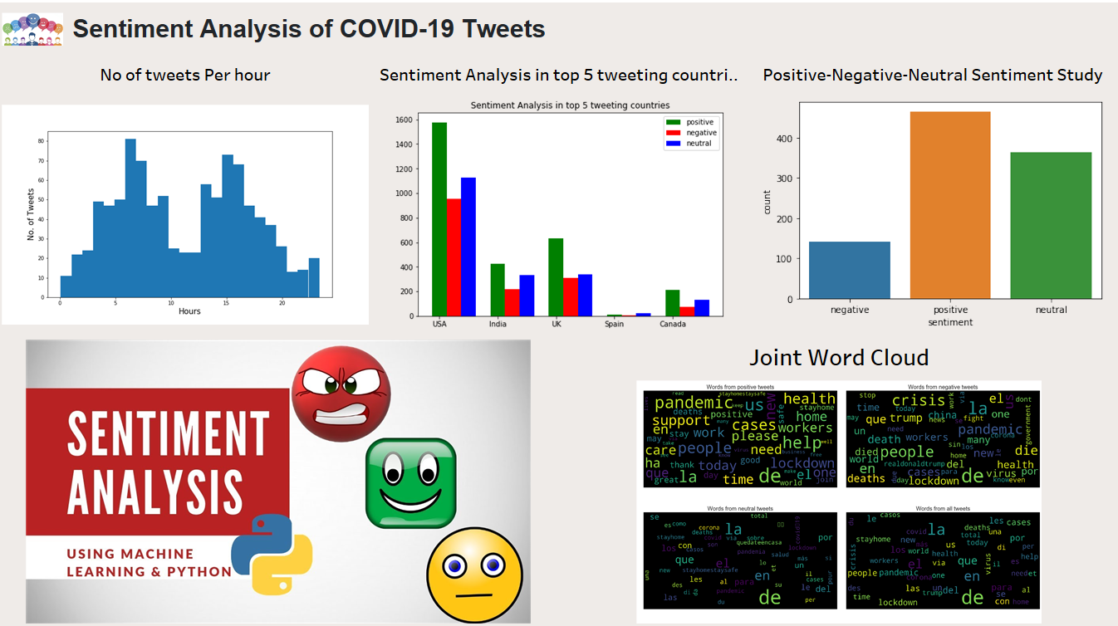

Sentiment Analysis Dashboard 2

## 

CORONA Confirmed Cases Dashboard:

<https://public.tableau.com/profile/sakshi1973#!/vizhome/Book1_15935966930610/Dashboard3>

CORONA Confirmed Deaths Dashboard:

<https://public.tableau.com/profile/sakshi1973#!/vizhome/Book1_15935966930610/Dashboard2>

## APPLICATIONS

Informational: Provides basic information such as tweets are positive, negative, or neutral.

Conversational: More complex than informational. Educate your clientele about what is the nature of tweets, rather than providing basic information.

News: it will help to the user to take any kind of deciding what kind of product we should launch or not at that time.

Fun Experiences: Think out of the box by encouraging your customers to engage with your product in new exciting ways.

## FLOWCHART

### Sentiment Analysis

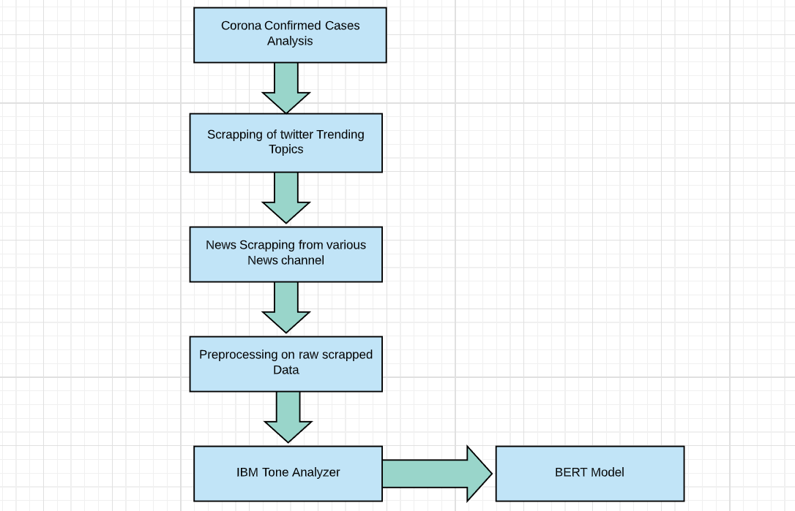

## Dashboard

## 

## RESULT

The main feature which we applied in our project(The Voice Assistant feature)will help to the users. It will help the user to take any decision. In our project, we analyzed the sentiments of COVID-19 related tweets in several ways. The overall trend shows that the public has been more optimistic over time. Digging into the multidimensional sentiment analysis, we found that the sentiment “Assertive” went up, and “Fearful” went down through the time. Besides, the Sentiment Density indicates that the public turned out to be less loaded with emotions. At last, the topics behind the sentiments unfolded more details. To fight the coronavirus not only needs the guidance from the government but also a positive attitude from the public. Our analysis provides a potential approach to reveal the public’s sentiment status and help institutions respond timely to it.

## ADVANTAGES & DISADVANTAGES

### ADVANTAGES

#### Can get things done fast:

It is faster to give a voice command when you are busy with some other tasks to get a task completed.

#### Improve your Speech Recognition Skills

You are training yourself on how to talk to a computer by using speech recognition devices. Many businesses are now incorporating speech recognition into their operations.

#### It will increase employment

This can be helpful when you are looking for jobs that require this skill set or you have to face with robot job interviewers.

#### Help you save time

If you know how VUI device works, it can be like an extra hand for you and helps you save a lot of time.

#### VUI Technology is Evolving

VUI technology is continuously improving. Communication with the machine is becoming more and more like human conversation and lesser and lesser like robotic. This demonstrates that the researchers are doing their best to improve the VUI devices in a way that will fit into human society.

### DISADVANTAGES

#### Voice Assistant Devices are Expensive

Voice Assistant devices which are controlled by the virtual assistants are expensive, and not everyone can afford them. They also consume a lot of electricity.

#### Leads to lost concentration on the task in hand

Using a virtual assistant with voice recognition can cause you to lose concentration on the tasks in hand.

### Privacy Concerns

While we will use voice commands, it can disturb privacy to humans. Due to privacy concern humans try to avoid using this device.

## CONCLUSION

We have addressed issues surrounding public sentiment reflecting deep concerns about Coronavirus and COVID-19, leading to the identification of growth in fear sentiment and negative sentiment. We also demonstrated the use of exploratory and descriptive textual analytics and textual data visualization methods, to discover early stage insights, such as by grouping of words by levels of a specific non-text variable. Finally, we provided a comparison of textual classification mechanisms used in artificial intelligence applications, and demonstrated their usefulness for varying lengths of Tweets.

## FUTURE SCOPE

We can add more voice command and do it more specifically. Our project will behave as much as good However command we will add in it. One of the biggest challenges for Sentiment analysis is being able to capture the context in which the sentence is being presented and it is tone. Sarcasm is one the biggest problems that common Sentiment analysis systems face. Improvement in being able to understand the context is something the researchers are currently working on.

## BIBILOGRAPHY

* <https://github.com/CSSEGISandData/COVID-19>
* <https://www.cnn.com/search?size=100&q=corona>
* <https://www.machinelearningplus.com/nlp/topic-modeling-gensim-python/#2prerequisitesdownloadnltkstopwordsandspacymodelforlemmatization>
* <https://cloud.ibm.com/apidocs/tone-analyzer>
* <https://colab.research.google.com/drive/1Y4o3jh3ZH70tl6mCd76vz_IxX23biCPP>
* <https://help.tableau.com/current/api/js_api/en-us/JavaScriptAPI/js_api.htm>
* <https://www.youtube.com/watch?v=x_5kH26xics&list=PLjlJJFiCdXMJtwhuWTSQ36VmKsZ8DqUZt>
* <https://ieee-dataport.org/open-access/corona-virus-covid-19-tweets-dataset>